Thomas Erben Gallery

Press Release

Dona R. Nelson
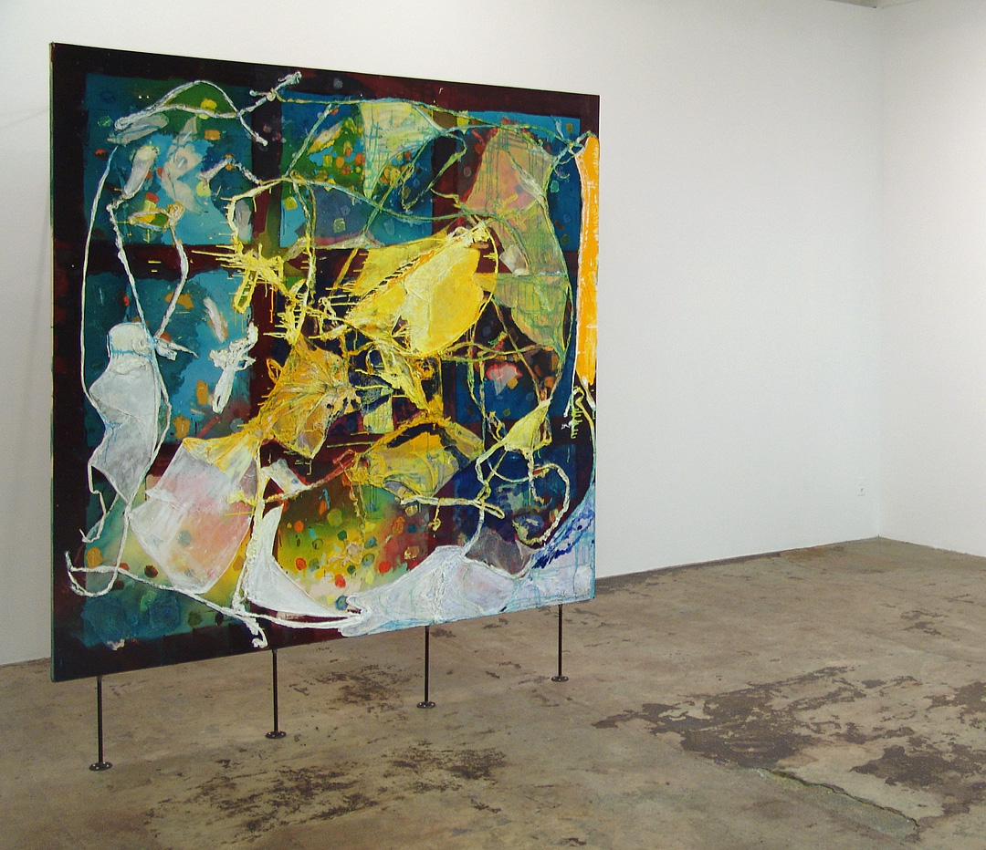
VOLTA NY, Booth D11
7 West 34th Street, 11th Floor
(between 5th/6th Avenue)
New York, NY 10001
www.voltashow.com
www.thomaserben.com

[place holder image]
Night Studio (2008), 83.5 x 84 inches,
acrylic media and cheesecloth on canvas

Thomas Erben is pleased to announce a solo presentation of Dona Nelson’s paintings at VOLTA New York, Thursday through Sunday, March 4–7, 2010.

In a recent article in the New York Times [2/14], art critic Roberta Smith specifically points out Dona Nelson as one of New York’s artists who deserve much broader visibility and recognition within our city’s art institutions. We can only second this assessment by presenting the artist at the VOLTA art fair and concurrently in a group exhibition, Animate Matter (February 23 through April 3, 2010), at our gallery space in Chelsea. Thomas Erben Gallery has been committed to showing Dona Nelson’s work, who we consider one of the most intellectually and formally engaged painters of our time. Nelson keeps pushing the boundaries of her chosen medium and, thus, constantly challenges our understanding of it.

The focal point of Dona Nelson’s solo presentation at VOLTA will be "O K", a two sided painting of delicate ridges of frosting white on the front and dense green, cut with spills of white paint, on the back. OK, according to Wikipedia, is "a grammatical particle which does not modify any other particular word, but rather reinforces the general point being made, particularly if that point is being called into question." OK is a sound or an exclamation or an interjection that stands alone, but if one separates O from K, the meaning (the affirmation or whatever) disappears. The letter O cannot be separated from the letter K; however, the two letters look completely different from one another, like the two sides of her painting, "O K."

Over the years, Nelson’s work has received extensive critical support including numerous reviews in the New York Times, Art in America, The New Yorker, The Village Voice, and Artforum. Her work has been favored and discussed by many notable curators and historians such as Lucy Lippard, Klaus Kertess, Lisa Liebman, and Sanford Schwartz. The Metropolitan Museum of Art, the Weatherspoon Art Museum, the Guggenheim Museum and other notable institutions as well as private collections have included Nelson’s work in their holdings.

Thomas Erben Gallery
526 West 26th Street, 4th floor
New York, NY 10001
212-645-8701
info@thomaserben.com

